**After installing AWC patch 3.2 if we require certain command icons to be displayed**

Then we need to install that feature seperately.As in Below example

We need this command icon to be displayed in AWC web client.

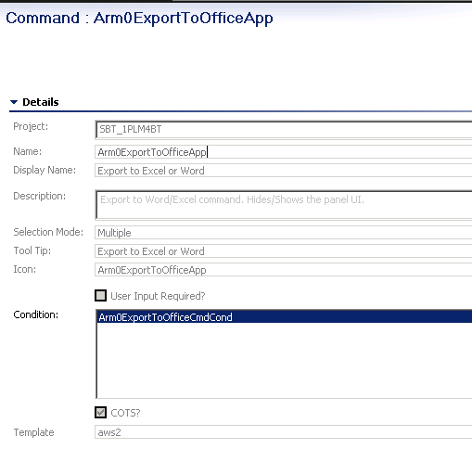

In Active Workspace ->Client->**Requirement Management** to display above icon as well as

Active Workspace ->Server Extensions->**Requirement Management**

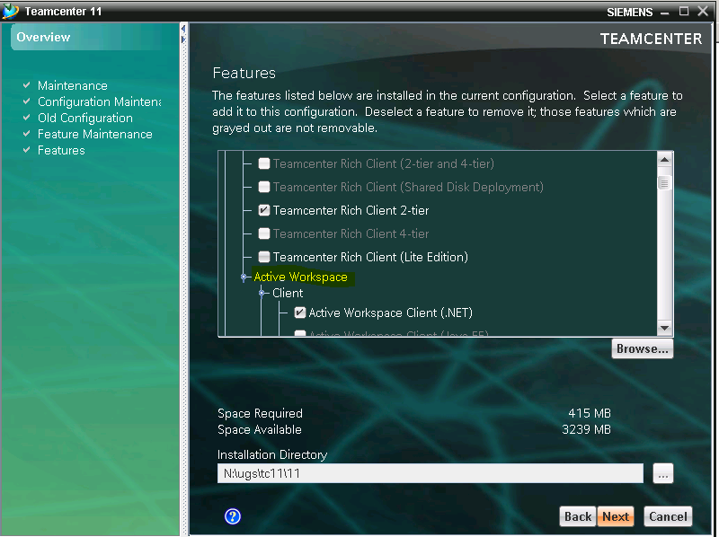

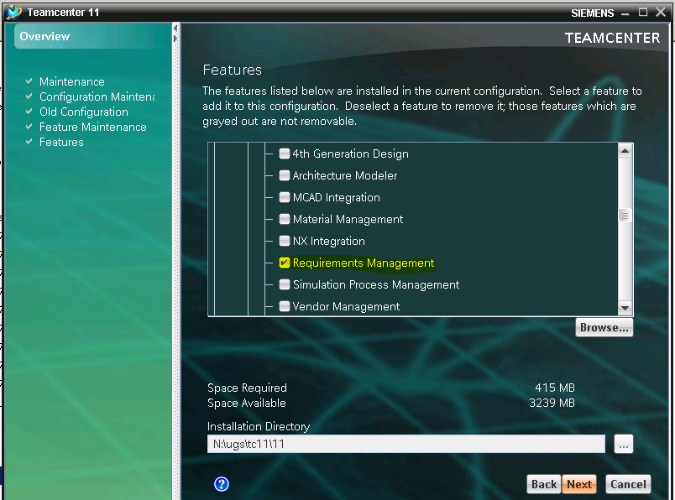

This icon displays in AWC like this.

